|  |
| --- |
| 新东方在线英语学习 |
| 新概念 1 册 |
| Lesson93-94 |



扫一扫。更多有趣的英语资讯。

# Lesson 93 单词讲解

1. pilot: 飞行员pai lei te
2. return: 返回

redo: 重做rewrite: 重写remarry: 再婚review: 复习

* 1. go back

return from\to

从…返回, 返回到…

He will go back from New York next month. he will return from New York next week.

She will go back to China next week. She will return to China next week.

* 1. send back 还



I am going to return the books.

我打算去还书。

He will return me my money next week.

他下周要还我钱。

He will return the coat he bought yesterday.

他要把昨天买的外套退了。

You cannot return things you have bought.

你没法退掉你已经买的东西。

* 1. give in exchange ai ke si change 类似礼尚往来

She is only one, but she is clever to return goodbye. 她才一岁，但已经聪明到懂得给人回应打招呼了。They are going to return the visit next week.

他们准备下周去回访。

1. New York: 纽约
2. Tokyo: 东京
3. Madrid: 马德里
4. fly: 飞行
   1. fly- flew-flown
   2. fly from\to ,从…飞回, 飞到… 下周他将从纽约飞回来。

He will fly from New York next week.

下个月她将飞回中国。

She will fly to China next month.

# Lesson 93 课文讲解

1. He is…

He was… He will…

He flew to…

He has already been to….

1. He’s only forty-one years old, and he has already been to nearly every country in the world.
   1. 年龄的表达：

41 岁：forty-one year- old

* 1. 全世界几乎每个国家 全国几乎每个城市：

nearly every city in China 全北京几乎每个的地方nearly every place in Beijing

# Lesson 93 语法讲解

句子的种类：

1. 简单句
2. 并列句
3. 复合句并列句：
4. 结构：

简单句+ and\but\so+ 简单句

He loves me and I am happy.

He loves me but I am not happy. He loves me so I am happy.

1. and, but, so, or…

not only … but also… 不仅…而且… He’s only forty-one years old,

and he has already been to nearly every country in the world.

1. 主次？没主次
2. 时态？

# Lesson 94 单词句型讲解

（看书背）

Athens 雅典 ai fen si

Berlin be er lin 柏林

Moscow mao si gou 莫斯科

Rome 肉mu 罗马

Stockholm s dao kou m

斯德哥尔摩

Geneva zhi no wa

Sydney sei ni

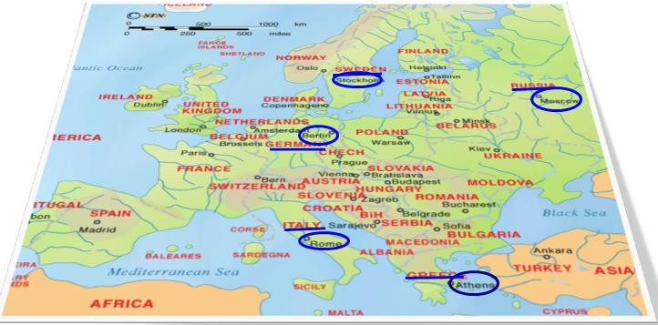

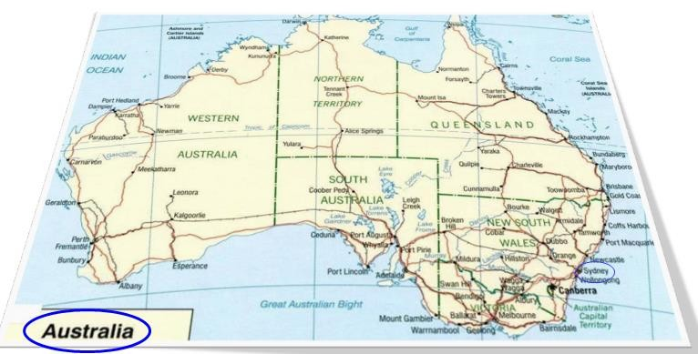

综合应用各种时态；

# Lesson 93&94 知识拓展

